***EXP5-Administrive Task RIYA INDAP,44***

***1)Process management***

~ps( tool that allows you to view information about the processes running on your Linux system)

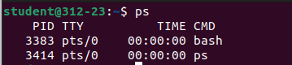

~pstree( a Linux command that shows the running processes as a tree)

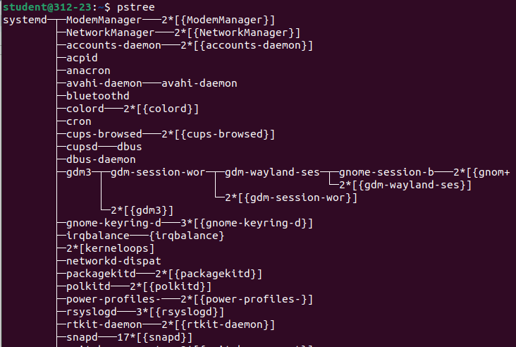

~pstree -p(shows detailed running processes as a tree)

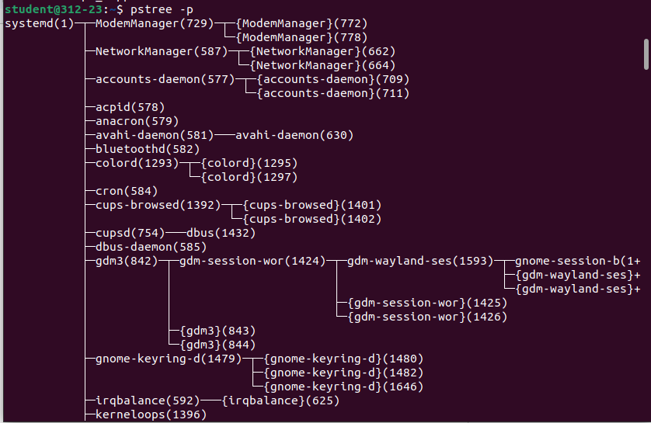

~pidof firefox(used to find out the process IDs of a specific running program)



~nice -n 8 firefox(determines the priority of the process)

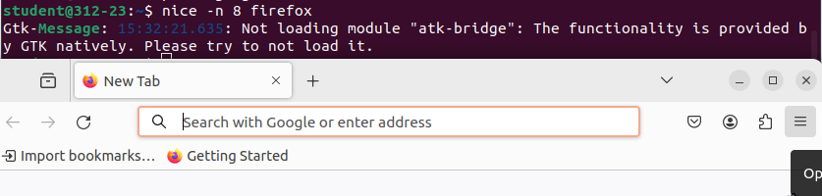

~renice -n ( causes all processes in the process group to have their scheduling priority altered)

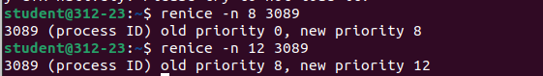

~pgrep -u root,daemon(a tool that searches for processes based on their name and other attributes, and returns their PIDs)

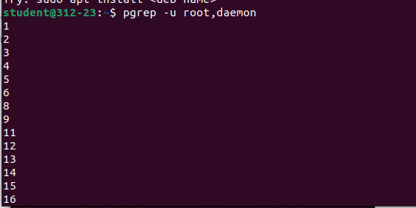

~kill( used to send a signal to a process, typically to terminate it)

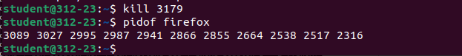

***2)Memory Management***

~top(used to show the active Linux processes)

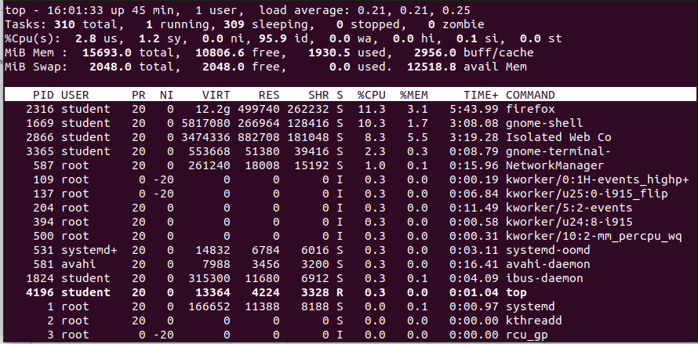

~free(provides a snapshot of the physical and swap memory, as well as the buffers and caches used by the kernel)

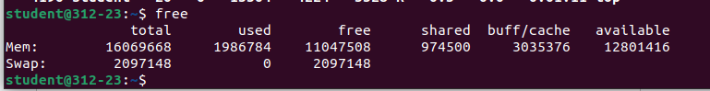

~cat(The 'cat' command can be used to copy the content of a file into another file)

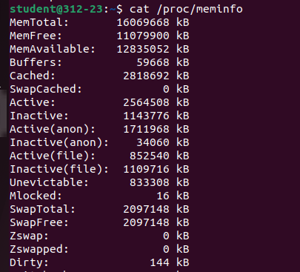

~vmstat(tool that reports various bits of system information)

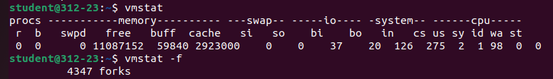

~htop( tool in the Linux environment to determine the cause of load by each process)

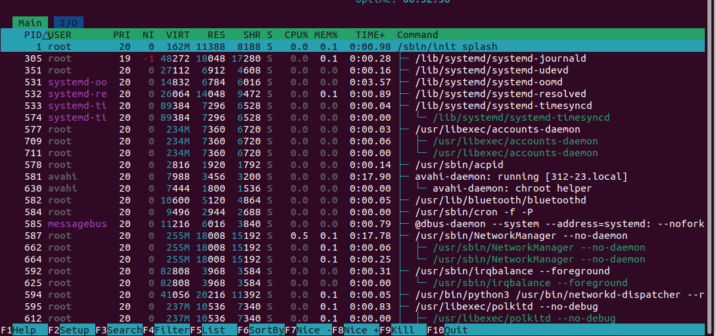

~ipcs(to list System V InterProcess Communication System's API kernel entities to stdout.)

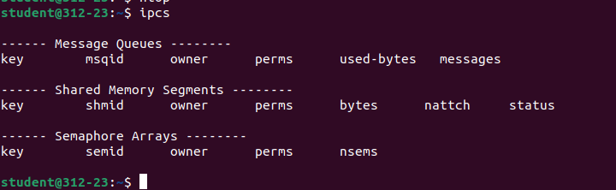

~ipcs -s(allow processes to exchange information, share resources, and communicate with one another)

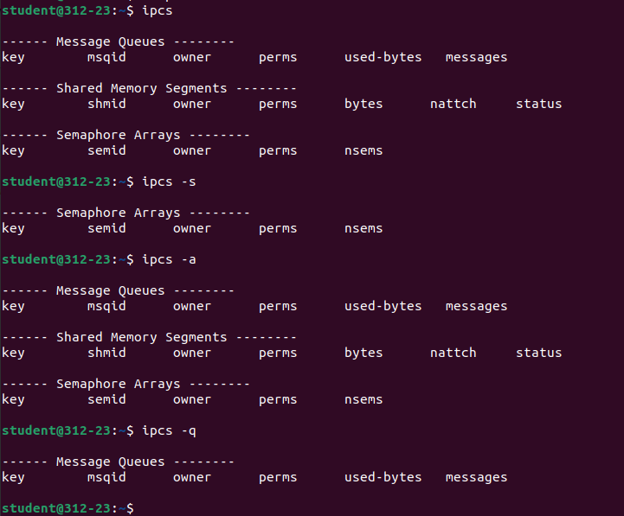

~ipcs -a



~ipcs -q(to list System V InterProcess Communication System's API kernel entities to stdout)



***3)File System Management***

~fdisk -l(used to create partitions on a block device.)

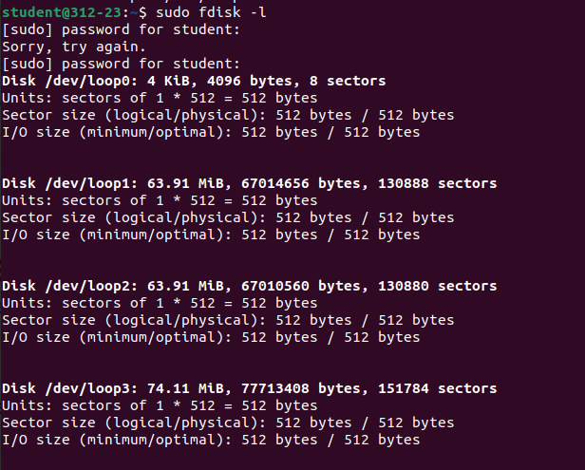

~df(displays information about total space and available space on a file system)

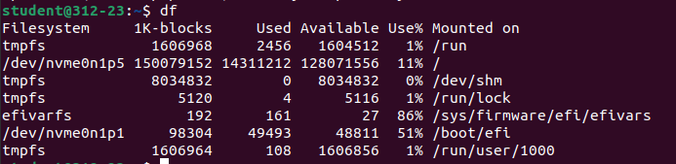

~du(used to estimate file and directory space usage.)

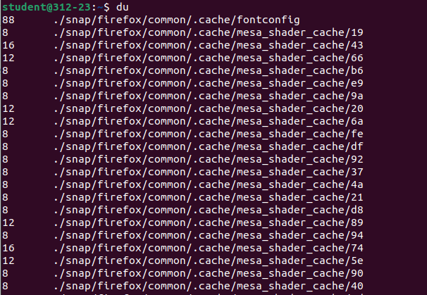

~mount(sed to attach a file system to a specific directory in the file system hierarchy)

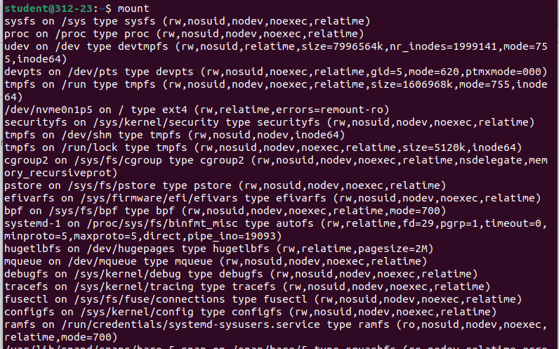

~mount -t ext4

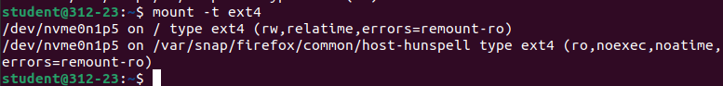

~umount(To unmount a file system in Linux)



~lsblk(used to list out all block devices in a tree-like format)

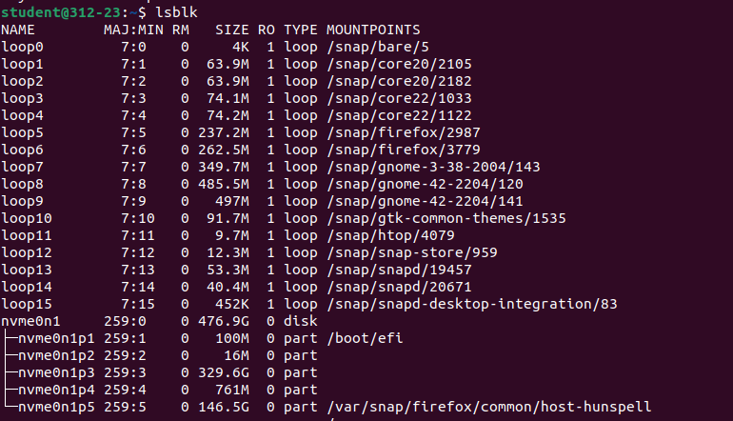

***4)User Management command***

~cat /etc/passwd ( To view it, we can use any regular file viewer command such as cat, less, more, etc.)



~addgroup(to add a new group to your current Linux machine)



~Cat /etc/group(to list all the groups)



~delgroup(Delete a group named sales that exist on Linux)



~groupmod(used to modify or change the existing group on **Linux** system)





~usermod(to change the properties of a user in **Linux** through the command line.)



~id (used to confirm the identity of a specified Linux user)



~userdel(deleting specified entries which refer to the username LOGIN)

